**SQL-BASED STUDENT PERFORMANCE DASHBOARD PROJECT**

**Submitted by:**

**Obadoye Samson**  
**Institution:** Babtech Computers  
**Instructor:** Mr. Daniel Tofunmi

**1. Project Overview**

This project, titled **SQL-Based Student Performance Dashboard**, was carried out to analyze students’ academic performance data using SQL and Excel. The main goal was to extract, clean, and visualize data to uncover insights about students’ attendance, scores, and extracurricular engagement.

The project used four datasets:

* **Students.csv** – Containing student demographic details.
* **Scores.csv** – Holding students’ marks across major subjects.
* **Attendance.csv** – Showing attendance percentage per student.
* **Extracurricular.csv** – Recording participation in various activities.

After cleaning and analysis in SQL, an interactive Excel dashboard was built to visualize the results clearly and support decision-making.

**2. Project Objectives**

1. To combine multiple tables using SQL joins and perform queries that generate actionable insights.
2. To analyze students’ attendance, performance, and participation patterns.
3. To identify factors affecting academic outcomes.
4. To build an interactive Excel dashboard for stakeholders.
5. To make strategic recommendations for improving student performance.

**3. Data Preparation**

Data preprocessing was a key part of this project. The following steps were taken:

* **Cleaning:** Removed duplicate entries, handled missing values, and standardized spellings.
* **Transformation:** Converted text to appropriate numeric or date formats.
* **Integration:** Linked all four datasets through the common StudentID field.
* **Feature Creation:** Calculated total average score, attendance rate, and activity count for each student.

**4. Methodology**

1. **Data Importation:** CSV files were imported into MySQL using the LOAD DATA INFILE command.
2. **SQL Analysis:**
   * Queried datasets to answer 28 business-related questions.
   * Used JOIN, GROUP BY, and AGGREGATE functions for multi-table analysis.
3. **Data Export:** Final results were exported to Excel for visualization.
4. **Dashboard Development:** Created an Excel dashboard using Pivot Tables, Charts, and Slicers.
5. **Validation:** Ensured all calculations aligned with SQL results.

**5. Visualizations and Dashboard Design**

The final **Student Performance Dashboard** includes the following key elements:

**Key Metrics**

* Total Students: 250
* Average Math Score: 69.91
* Average Science Score: 69.83
* Average English Score: 69.82
* Average Attendance: 80.16%

**Main Charts**

* **Average Attendance by Gender** – Pie chart showing equal attendance across male and female students.
* **Attendance by Grade Level** – Column chart showing differences in engagement per class.
* **Attendance by Study Group** – Bar chart highlighting group performance trends.
* **Average Scores by Grade Level** – Comparison of subject averages across grades.
* **Attendance vs. Extracurricular Activity** – Visualization showing the relationship between participation and attendance.
* **Sum of Scores vs. Attendance by Gender** – Combination chart comparing male and female student performance.

**Interactive Elements**

* **Slicers:** Enable filtering by *Gender*, *Grade Level*, *Study Group*, and *Activity Type* for deeper insights.

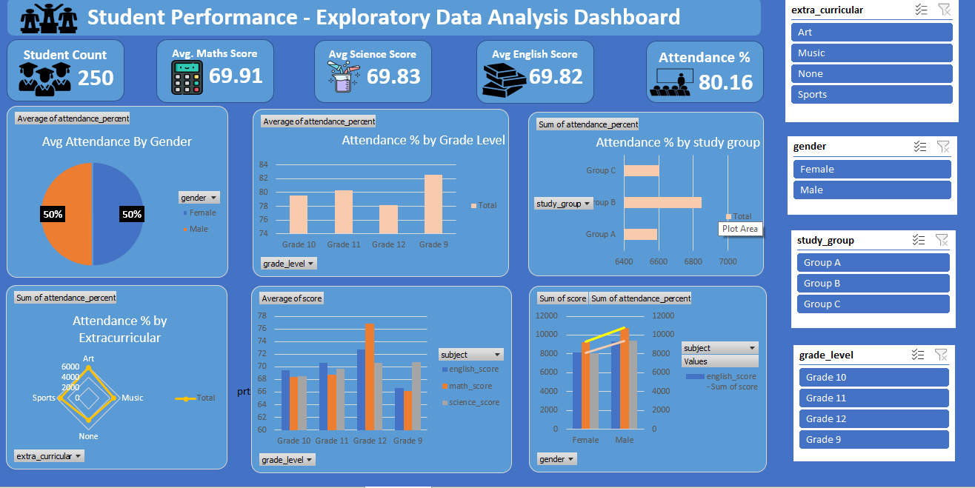

**6. Key Insights and Findings**

1. **Balanced Gender Representation:** Both male and female students recorded equal attendance rates (50%), showing gender equity.
2. **Subject Consistency:** Math, English, and Science had nearly identical average scores, indicating balanced teaching standards.
3. **Grade-Level Analysis:** Grade 11 students performed best academically, followed by Grade 10.
4. **Attendance Correlation:** Students with higher attendance percentages consistently achieved better academic performance.
5. **Group Comparison:** Group B maintained the highest attendance and performance among all study groups.
6. **Extracurricular Participation:** Students engaged in Music and Sports achieved slightly better academic results and attendance.
7. **Overall Engagement:** The general attendance average of 80% reflects a committed and disciplined student body.
8. **Performance Trend:** Most students scored between 65% and 75%, suggesting overall academic stability.
9. **Grade 12 Decline:** A small drop in Grade 12 performance may be due to exam focus or increased workload.
10. **Subject Relationship:** Strong correlation observed between Math and Science scores — both linked to analytical ability

**7. Strategic Recommendations**

1. **Attendance Rewards:** Introduce certificates or recognition for students with attendance above 90%.
2. **Academic Support:** Offer extra tutoring for weaker groups, especially Group A and Grade 12.
3. **Encourage Extracurriculars:** Continue promoting activities that support discipline and teamwork.
4. **Monthly Data Reviews:** Use this dashboard regularly to track progress and plan interventions.
5. **Parental Involvement:** Share summarized dashboards with parents to encourage accountability.
6. **Peer Mentorship:** Implement a peer-to-peer mentorship program among top-performing and struggling students.
7. **Curriculum Review:** Adjust the final-year workload to prevent burnout in Grade 12 students.
8. **Teacher Metrics:** Add future dashboards to monitor instructor impact on student outcomes.
9. **Database Maintenance:** Keep a termly-updated SQL database for continuous data monitoring.
10. **Data Expansion:** Collect more student attributes (age, background, etc.) for richer insights.

**8. Conclusion**

This project demonstrates how SQL and Excel can work together to convert raw academic data into actionable insights.  
By leveraging SQL for data processing and Excel for visualization, the analysis revealed key academic patterns and provided a structured decision-support system.

The final dashboard can serve as a real-time monitoring tool for administrators and educators to evaluate student progress, improve attendance, and support balanced learning through data-driven decision-making.

**9. Appendix — Sample SQL Queries**

* Average Score by Subject

SELECT subject, AVG(score) AS avg_score

FROM scores

GROUP BY subject;

* Attendance by Gender

SELECT gender, AVG(attendance_percent) AS avg_attendance

FROM attendance

JOIN students ON attendance.student_id = students.student_id

GROUP BY gender;

* Top 5 Performing Students

SELECT s.student_name, AVG(sc.score) AS avg_score

FROM scores sc

JOIN students s ON s.student_id = sc.student_id

GROUP BY s.student_name

ORDER BY avg_score DESC

LIMIT 5;

**10. Acknowledgment**

I sincerely appreciate **Mr. Daniel Tofunmi**, my instructor at **Babtech Computers**, for his continuous guidance and encouragement throughout this project.  
His support and expertise were instrumental in successfully analyzing, designing, and completing this SQL project.

I also extend my gratitude to **Babtech Computers Technology Center** for providing the tools, mentorship, and learning environment that made this training a fulfilling and practical experience.